**Professional Practice Assignment**

**Tivadar Debnar**

**Computing**

**Introduction**

***Professionalism*** in today's word is essential, and one of the most significant factors in our level of success in a chosen career. It is a transparent display of ***attitude towards trade*** and our ***company***. According to Sylvia R., "a profession is an occupation, whose core element is work, based upon the ***mastery*** of a complex body of knowledge and skills" (Sylvia R. *2004*). Furthermore, professions are occupations that need an extended period of tutoring and training.

The word professional practice means the conduct and work of someone from a particular profession, and it defines a set of ***standards*** of how an individual behaves in the workplace, his performance, ethics, competence, training and so on that must be met to remain and succeed within the profession.



**Figure 1** - Equal Experts Logo

***Equal Experts (EE)*** is a London based company offering a wide range of IT solutions from web applications to mobile and data services. As a junior IT trainer of EE, I was given a task of organising a two-day seminar about security vulnerabilities in web-applications which will be open to the public and welcomes IT security experts from our business partners, freelancers as well as independent ethical hackers. Throughout the implementation of this conference, we will give demonstrations of several aspects of professional best practices and discussing their methodologies.

**Demonstrate different communication styles that you can effectively design and deliver a training event for a given target audience.**

Categorised as interpersonal (soft) skill, the capability to communicate information and knowledge accurately as intended is a fundamental skill that must not be ignored in any aspects of life, let it be personal or professional. Communication is the action of ***distributing information*** from one person to another person or people. "The field of communication focuses on how people use messages to generate meanings within and across various contexts, cultures, channels, and media" (*Korn, C. J., 2000*). Throughout the preparations and delivery of the seminar, several channels of communication will be used.

When talking about communication, many people immediately associate to language and speaking in general; however, it is just the verbal or vocal channel of communication. To verbally communicate effectively, one must not only use a confident speaking voice and articulate well - so the ideas and information are ***transmitted clearly*** - but intently use active listening as well. While passive listening is the mere act of hearing a speaker without apprehending the message, ***active listening*** is a skill to concentrate entirely on a speaker, comprehend the information and respond thoughtfully. Active listening is applied through some practical techniques.

* By ***paraphrasing***the speaker, we have the opportunity to clarify obscure or vague information and summarise main points, which not only helps the comprehension of a topic but contributes to the process of better memorisation.
* The use of open-ended or specific ***probing questions***, confirm that we gathered the essence of what has been shared and encourage the speaker into sharing additional information or narrow down a broader subject.

Using body language, facial expressions and gestures that convey information is called the ***non-verbal communication*** channel, and it is often used instinctively rather than consciously. "The total impact of a message is equal to a 7% contribution from the verbal channel, a 38% contribution from the vocal channel, and a 55% contribution from the facial channel" (*Hegstrom, 1979*). Considering that ***more than half*** of our delivery comes through non-verbally, let's examine the impact and role it plays in communication. It can:

* Strengthen or repeat the verbal message, emphasising it.
* Contradict the message, indicating to the listener that we may not be telling the truth.
* Substitute for a verbal message. For instance, the facial expression often conveys substantially more expressive message than words.
* Complement verbal message. Pat someone on the back in addition to giving praise, increase the impact of appreciation.
* Accent a verbal message. Pounding the table can stress the weight of the situation.

We, at Equal Experts, utilised our knowledge of non-verbal communication when selecting our seminar-speaker by watching sample lectures from many candidates, scrutinising all aspects of the candidates' communication. Our choice fell on Andrew Davis – an experienced consultant from MySpace - whose ***body language*** was ***genuinely open*** and his delivery was energetic throughout all his seminar samples.

Any message exchanged by the use of written words and symbols is written communication, and it is the most common ways of communication in business. This channel of communication relies on grammar, punctuation and vocabulary. Developing written communication skills demands training, practice and adequate attention to detail. The following examples can help to improve written communication skills:

* Clarity: The use of simple language and sticking to the concrete, specific information.
* Conciseness: Get to the point quickly and efficiently.
* Tone: In business writing and emailing, our style is professional, combined with formality and friendliness.
* Active voice: It is usually more accessible and more comfortable to follow for readers than the passive voice.
* Grammar and punctuation: It’s crucial for ensuring that our point is getting across.

As professionals at Equal Experts, my team has always had a keen eye on written communication protocols. Emails sent in-house are ***concise***, ***on-point*** and ***accurate***, and grammar mistakes are frowned upon by management; however, the tone is friendly and approaching. Emails sent to customers and business partners are written in a more ***formal*** nature and always proofread.

Responding email to the proposal of the catering company CAIGER & Co.-s manager, Alix Caiger:

Dear Alix.

Thank you for your proposal. We genuinely appreciate the effort that you have put in submitting such a comprehensive catering plan for our company.

We do understand that you have spent considerable time and resources to come up with this function, which outlines in details how you are going to provide food and beverage services for the interval of the two-day seminar.

My team and I reviewed the entire proposal in detail, and overall, we are delighted about it.

Kind regards, Tivadar Debnar.

Email to the Engagement Lead, Ambika:

Hi, Ambika!

I'm coordinating this year’s web security seminar and would like to get some more input on the venue. The event specifications are listed below:

* Date: 06.02.2020 - 07.02.2020.
* The number of guests: 70.
* Sandwiches are served at 10:00 and hot food at 13:00.
* Vegetarian and gluten-free options are available.
* Drink bar offers soft drinks and coffees.

The estimated cost is £50 - 55 per day per person (inclusive of tax), which fits our budget (£60).

The venue is available on the given date (Makers, Shoreditch).

Please advise on your preference for hot food menu items and sandwiches - see menu attached.

I look forward to hearing from you.

Have a nice day!

Tivadar Debnar

**Practical time management skills.**

“Time management refers to ***planning*** the ***time available*** in line with personal goals and lifestyles, while keeping individual preferences, likes, and dislikes in mind. The criterion for efficient time management lies not only in achieving set goals, but also in attaining them in the ***minimum time possible***.” (Kaya, 2012)

Several skills and actions that need to be applied to carry out successful and professional time management.

* ***Goal-setting***: My ***first step*** was to schedule a meeting with management and all team members to define our ***end-goal*** and consider all specifications and necessary resources.
* ***Prioritisation:*** the cardinal tool we need to complete the project that has multiple components is a ***master to-do list.*** We factor in all the necessary sub-routines, that will be analysed, ranked and categorised according to their importance into ***do*** (complete), ***defer*** (complete later), ***delegate*** (assign it to a third-party) and ***delete***.
* ***Planning:*** structuring and allocating time and resources into a strict ***schedule***. As the employee responsible for the general organisation of the seminar, I spent the rest of the day, creating an overall plan.
* ***Delegation:*** following the created schedule, I assigned responsibility to team members in line with their skills and position. As a result, every participant is ***accountable*** for their particular task.
* ***Organisation:*** managing workload in a systematic way, such as file management, emails, reminders and alarms, and even organising workspace.

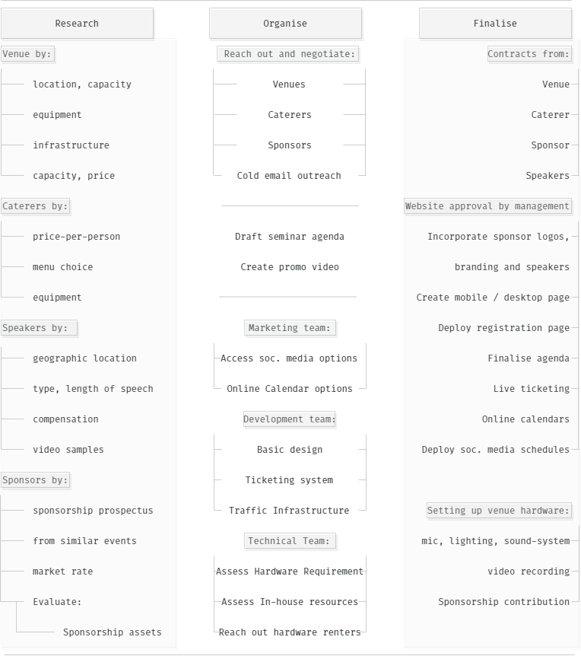

**Figure 2** - Work Breakdown Structure

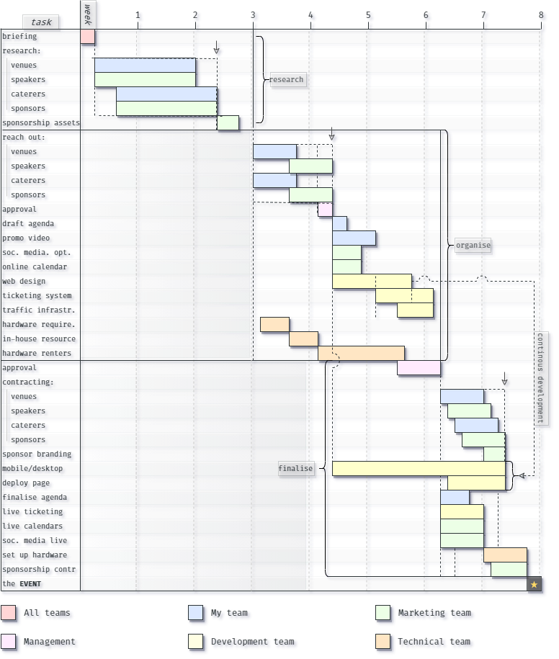

**Figure 3** - Grantt Chart

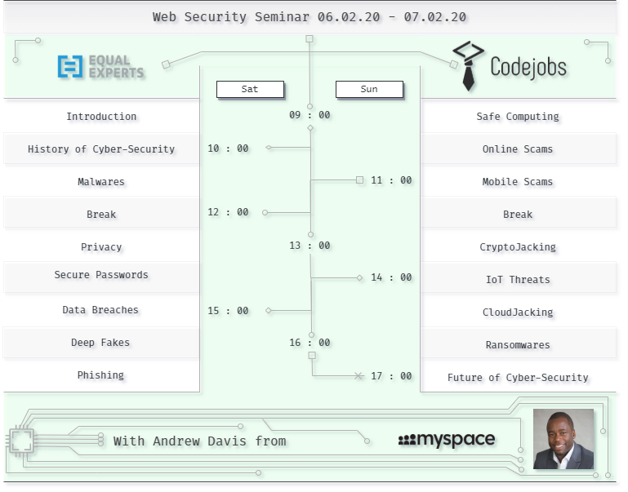**Figure 4** - Agenda with Sponsor Logo

**Evaluation**

Throughout the organisation of the project, we used various interpersonal skills that led to the success of the seminar. Without professional communication technics, the project could have never been organised smoothly. Additionally, utilising these soft skills helped us finding our sponsor for the event as well, significantly reducing the overall cost of the project.

**Problem-solving**

*"Problems are only opportunities in work clothes."* – Henry Kaiser (American industrialist)

Problems are fundamental and necessary building blocks of our professional and every-day life. The ***mentality*** and a consistent ***methodology*** of how we ***perceive*** occurring problems not only shape our career but significantly determines our private life, as well as our mental health.

Equal Experts expects employees to have a positive and confident attitude towards new challenges, also encourages an overall optimistic view of our business and professional development through several steps of problem-solving.

* **Defining the problem and its attributes**: We need to make sure that we are dealing with the *"real"* problem, not a side effect or a symptom of a different issue. A perfect example is a manager blaming employees' attitude for substandard performance, while the underlying issue might be the lack of training or vaguely defined responsibilities. The problem needs an ***accurate description*** with specific features.
* ***Check for existing solutions***: The chances are that a given problem has already been solved by someone else. Try not to re-invent the wheel!
* ***Creating a set of options:***We cannot pick a solution until several ***alternatives*** have been proposed considering the interest of every participant. At Equal Experts, this step is all about ***brainstorming*** and creativity. As Alfred Nobel said, *" If I have a thousand ideas and only one turns out to be good, I am satisfied"*.
* ***Evaluation:*** Every alternative must be assessed according to their ***possible outcomes*** and acceptability constraints, eliminating unviable ones. Prioritise effective, efficient options, which consequently have the least side effects in implementation.
* ***Implement the first alternative:***Implementation should be iterative, leaving space for adjustments and optimisation.
* **Monitor results:** More often than not, we need to experiment with several alternatives until we find the optimal one.

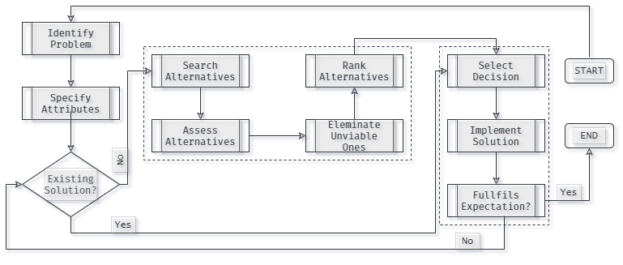

**Figure 5** - Decision Making Flow Chart

**Problem-solving in practice**

At the first phase of the project, it became clear that the overall cost of the project might exceed our budget. Therefore, I arranged a meeting with the departments involved to find a solution for reducing the cost.

Here below is a detailed diagram of the meetings decision-making process.

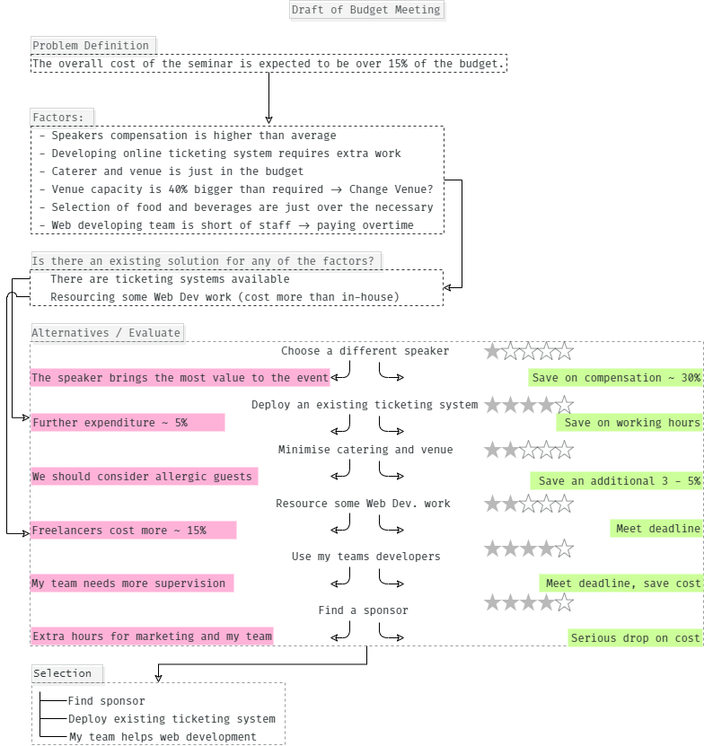

**Figure 6** - Implementation of problem solving

**References:**

Cruess, S. R., Johnston, S., & Cruess, R. L. (2004). "Profession": a working definition for medical educators. *Teaching and learning in medicine*, *16*(1), 74-76.

Korn, C. J., Morreale, S. P., & Boileau, D. M. (2000). Defining the field: Revisiting the ACA 1995 definition of communication studies. *JACA-ANNANDALE-*, (1), 40-52.

Hegstrom, T. G. (1979). Message impact: What percentage is nonverbal? *Western Journal of Communication (Includes Communication Reports)*, *43*(2), 134-142.

Kaya, H., Kaya, N., Palloş, A.Ö. and Küçük, L., 2012. Assessing time-management skills in terms of age, gender, and anxiety levels: A study on nursing and midwifery students in Turkey. *Nurse Education in Practice*, *12*(5), pp.284-288.